**Restore AWS instance using CPM**

Follow below Steps for restoring AWS instance using CPM.

**Important note:**

When you recover an instance, by default, you recover it with its configuration, tags, and data, as they were at the time of the backup. However, you can change these elements:

* **Instance type**
* **Placement**
* **Number of CPU cores and threads**
* **Architecture**
* **User data, etc.**

Below are the steps for recovering AWS instance using CPM backup tool.

In the Backup Monitor, you can search for snapshots based on the policy

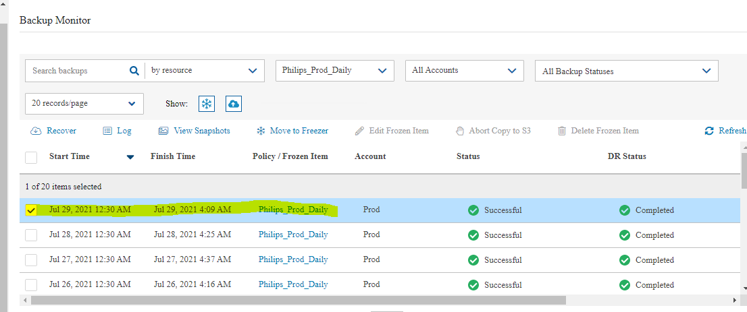

When you select **Recover** for a certain backup, you are directed to the **Backup Monitor** **Recover** screen. You can Search by Resource using the resource ID or name.

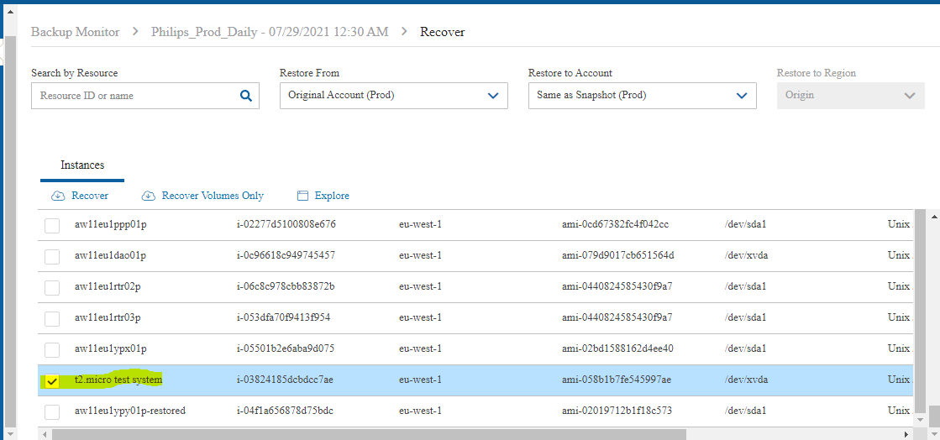

After selecting the resource we need to recover, we need to clikc on **Recovery** option.

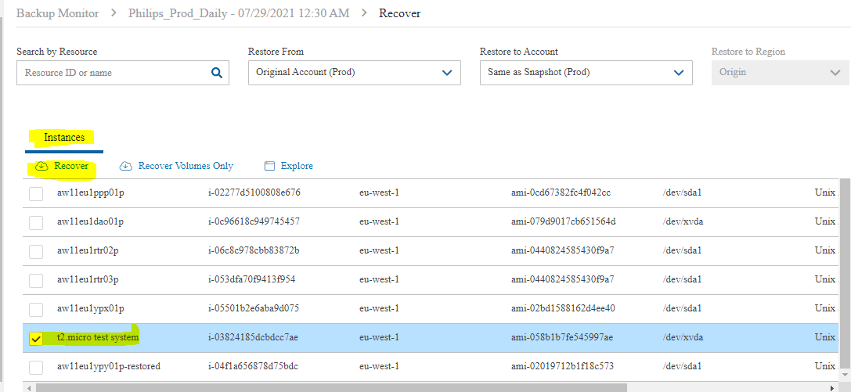

After clicking Recovery option, the **Recover** screen opens

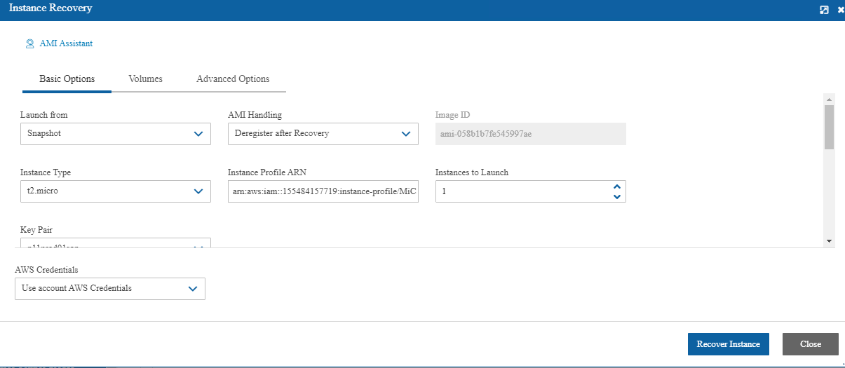

**Basic Options**

The **Basic Options** tab is divided into the general section and the Networking section:

By default, configuration is the same as they were at the time of the backup.

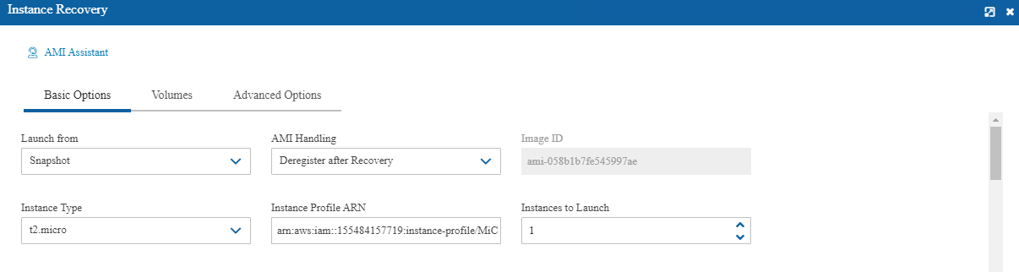

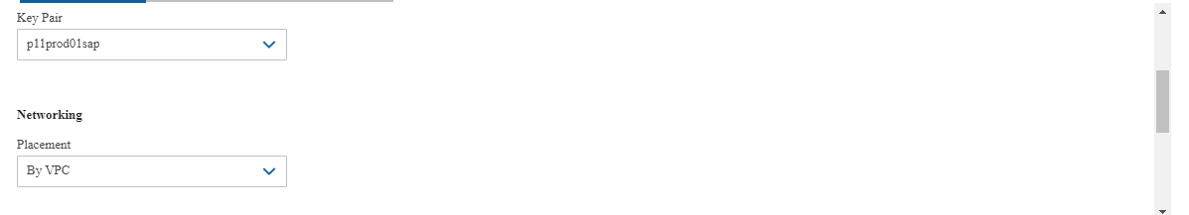

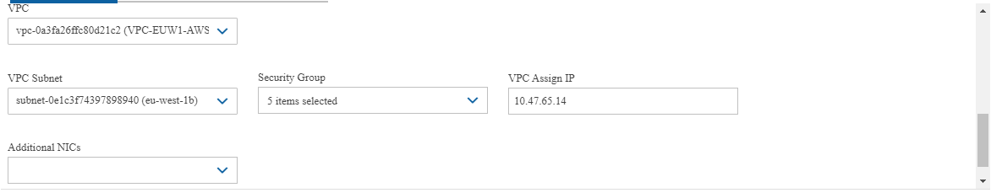

**Volumes**

By default, configuration is the same as they were at the time of the backup.

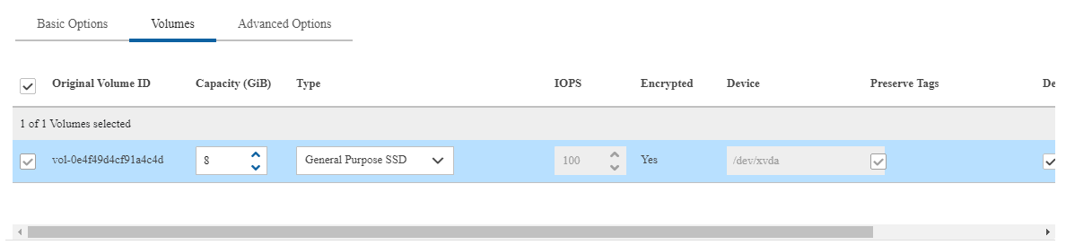

**Advanced Options**

By default, configuration is the same as they were at the time of the backup.

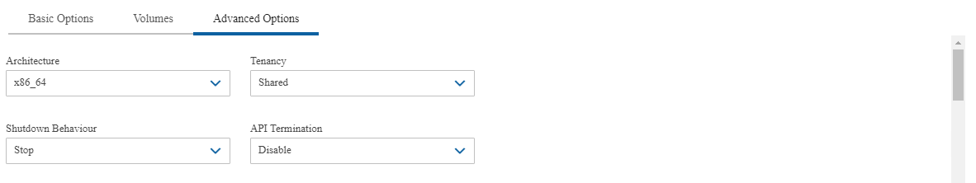

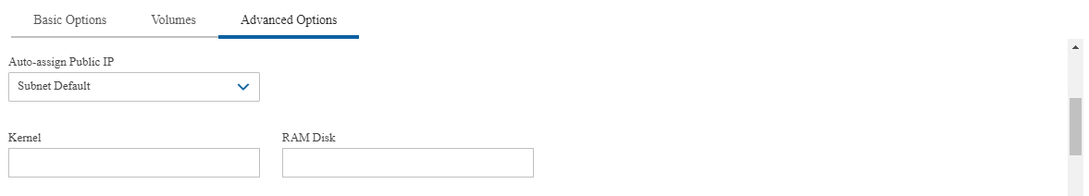

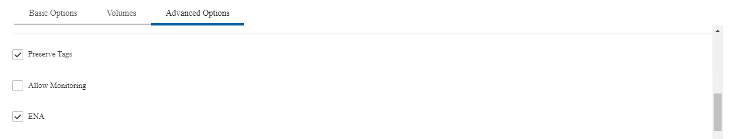

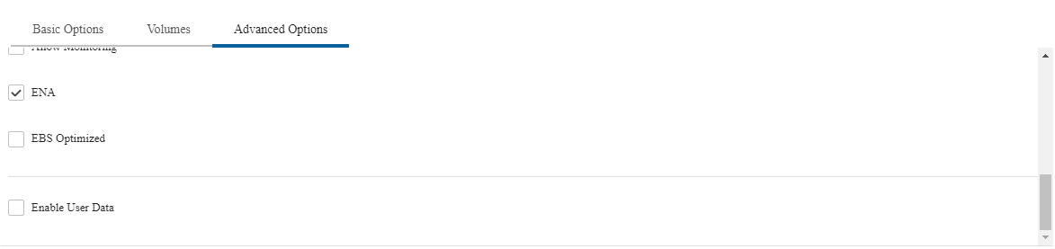

**Recover Instance**

We need to click recover instance to start the restore and after click recover instance, restore will start.

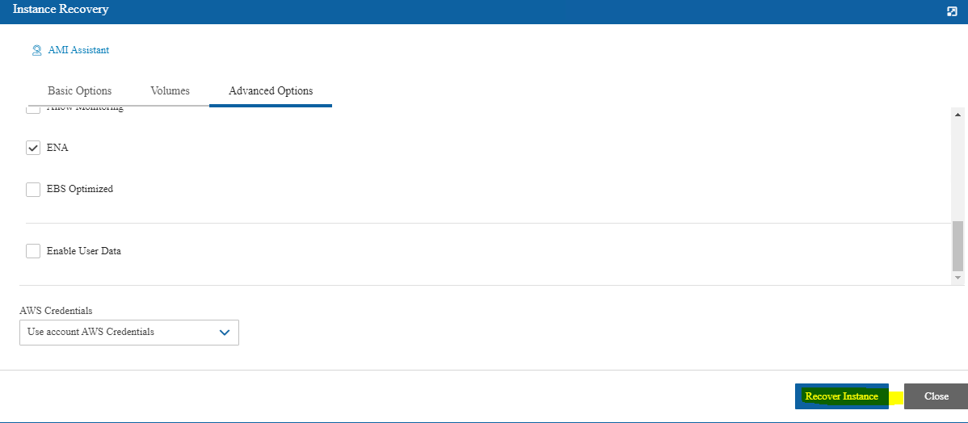

We can monitor restore job status on recovery monitor tab.

